**Project Design Phase**

**Solution Architecture**

|  |  |
| --- | --- |
| Date | 26 February 2026 |
| Team ID | LTVIP2026TMIDS43269 |
| Project Name | Flight Finder: Navigating Your Air Travel Options |
| Maximum Marks | 4 Marks |

**Solution Architecture:**

Solution architecture is a complex process – with many sub-processes – that bridges the gap between business problems and technology solutions. Its goals are to:

| **Parameter** | **Description (Copy & Paste)** |
| --- | --- |
| **Best Tech Solution** | ***MERN stack (MongoDB, Express, React, Node) for high-speed flight search.*** |
| **Structure** | ***Decoupled 3-tier architecture separating the UI from the database logic.*** |
| **Behavior** | ***Asynchronous data fetching with real-time "Booking Success" feedback.*** |
| **Features** | ***Dynamic city filtering, persistent booking history, and admin data seeding.*** |
| **Specifications** | ***RESTful API endpoints with JSON data exchange and Mongoose schemas.*** |

**Example - Solution Architecture Diagram:**

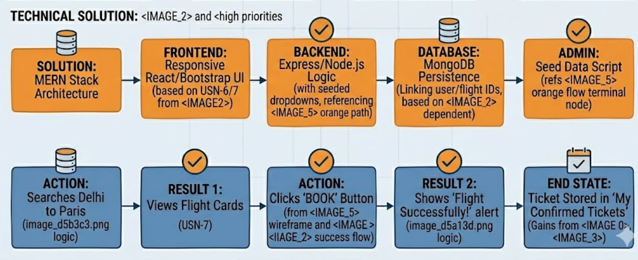

*Figure 1: Architecture and data flow of the flight Finder application*